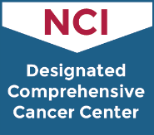

Spanish Speaking Support Group
- Are you in active treatment for cancer (such as chemotherapy, radiation, surgery)?

- Are you you looking to connect with others?

Attend our online virtual discussions to meet others facing the same issues

This is an excellent way to meet and interact with fellow patients. This will be a safe place to share your experiences, suggestions and support with others.
The online virtual group meets twice a month - every other Tuesday 2:00-3:00 pm
Register for one or more of these meeting dates!

Click on this Zoom link to register:
https://rutgers.zoom.us/meeting/register/tJwqf-ChqjksHNXabFGEtAkgm-9Z1xqqu4zk

Registration is required. If you would like to attend or have any questions, please contact Stephanie Quiroga,MSW, LCSW, LCADC at salbuque@cinj.rutgers.edu.

